FPGA-Based Image Enhancement: RGB2HSL/HSL2RGB Conversion
The Hue, Saturation, and Intensity elements control wider color range for image enhancement.
AdvancedShowcase (no instructions)477
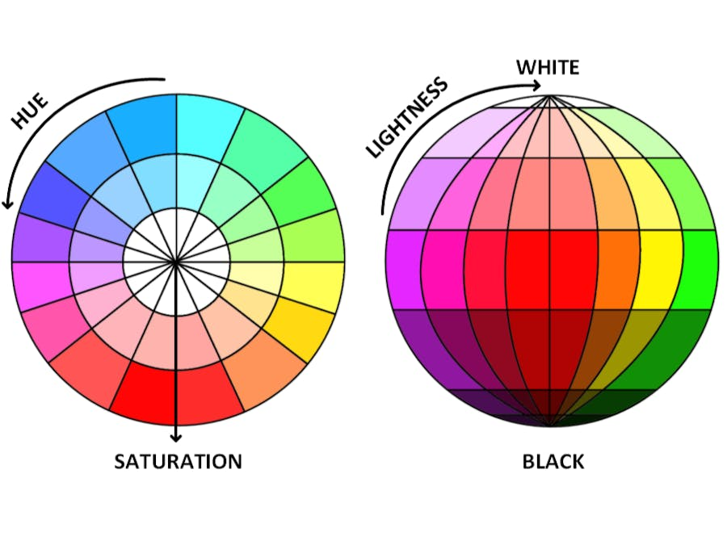
Things used in this project
Hardware components
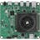 | AMD Kria™ KV260 Vision AI Starter Kit | × | 1
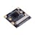 | Seeed Studio IMX219-130 8MP Camera | × | 1
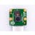 | Raspberry Pi Camera Module V2 | × | 1
Software apps and online services
 | AMD Vivado Design Suite
 | AMD Vitis Unified Software Platform
Story
HueSaturateLuminosity (HSL): Hue is a color range of degree from 0 to 360 which describe a pure color in angular quantity. Saturate is shade of gray to full color. Amount of saturation of color is known as chroma. Higher value of chroma is clear and bright. The strongest magnitude is value and its range correspond to brightness and balanced magnitude corresponds to the intensity. Hue color describe the pure color whereas saturate values determine pure color range strength and luminosity describe pure color range. The maximum saturation is at a medium grey intensity. A color with 100% saturation yields purest color and 0% yields grayscale. A color with 0% luminosity is black and 100% luminosity yields bright color.
Value of angles below are hue values on the color wheel.
- 0 degree – Red
- 60 degree – Yellow
- 120 degree – Green
- 180 degree – Cyan
- 240 degree – Blue
- 300 degree – Magenta
- 360 degree – Red-Magenta
RGB triplet saturation equation shown below where max, and min is calculated of between Red, Green, and Blue channel. It represents the strength of the color and the radius of the cone. RGB consist of equal amount of white light. When max rgb component is subtract with minimum RGB component and divided by max RGB component than grayscale intensity is eliminated. Thus, this new color has no white light and saturated and represent a single wavelength.
The RGB colors made stronger by increasing the saturation in HSL color space when converted from RGB to HSL and HSL to RGB.
RGB To HSL And RGB To HSL
The Hue, Saturation, and Intensity elements control wider color range for image enhancement. Video stream from camera is format of original RGB color space than transformed to HSL color space. In HSL color space, current Hue, Saturation, and Luminosity is linearly updated by multiplying coefficient values to each of the component to make image colors brighter and more colorful. After applied color gains to HSL components than HSL color space is converted back to RGB color space. In this process, the resulting enhanced image colors looks natural and brighter after applying multiplicative gain(weight) control to each HSL component.
RGB To HSL
The implemented rgb to HSL color space in video color processing module uses HSL algorithm, and it has been designed with a standard Xilinx AXI4 streaming interface, so that it can be inserted as a module within any image processing pipeline.
First logic calculates maximum and minimum value of RGB values. The max and min RGB value is calculated according to logic implementation as shown in Figure Below.
Hue is calculated by determining the hue fraction from greatest RGB channel value. If current max channel color is Red than Hue numerator will be set to Green subtract Blue only if Green is greater than Blue else Blue is subtracted from Green and Hue degree set to 0 to 85.
If current channel max color is Green than Hue numerator will be set to Blue subtract Red only if Blue is greater than Red else Red is subtracted from Blue and Hue degree would be 86-171.
Similarly, if current channel max color is Blue than Hue numerator will be set to Red subtract Green only if Red is greater than Green else Green subtracted from Red and Hue degree would be 172-255.
Hue denominator would be RGB delta.
Once Hue fraction values are calculated than fraction values would be added to Hue degree which would give final Hue value. Saturate value is calculated from difference between RGB max and min over RGB max whereas Lightness value RGB max value.
The module has clock and reset ports. Port iRGB consist of Red, Green, and Blue color components with valid signal, which is used to convert to RGB pixels to HSL pixels.
The simulation results of RGB channel conversion to HSL color space is presented in wave diagram Figure below.

HSL to RGB Conversion Module
The implemented HSL rgb color space in video color processing module uses HSL to RGB conversion algorithm, and it has been designed with a standard Xilinx AXI4 streaming interface, so that it can be inserted as module within any image processing pipeline.
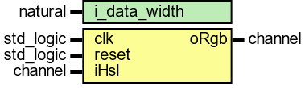
The video color processing module includes an HSL to RGB conversion algorithm. This module is designed with a standard Xilinx AXI4 streaming interface, enabling easy integration into any image processing pipeline. The primary function of the HSL to RGB module is to transform input values from HSL color space into RGB color space, ensuring compatibility with various video processing stages.
The module features clock and reset ports to support proper synchronization and initialization. The iRGB port handles the Red, Green, and Blue channel outputs, each accompanied by a valid signal. This signal facilitates the accurate conversion of HSL pixel data into corresponding RGB pixel values, supporting real-time video processing requirements.


iHSL to RGB VHDL Module: Data Flow Description

Function Overview
The iHSL to RGB VHDL module is designed to convert incoming HSV or HSL pixel streams, each 24 bits per pixel, into RGB streams of the same bit width, while maintaining video-style channel sidebands for synchronization and data integrity.

Interface Description

Inputs
- clk, reset: Clock and reset signals for module synchronization and initialization.
- iHSL channel: The input data channel with the following structure:
- iHSL.tdata[23:16]: H (Hue, mapped from 0–255 to 0–360°)
- iHSL.tdata[15:8]: S (Saturation, 0–255)
- iHSL.tdata[7:0]: L (Lightness, 0–255) or V (Value, 0–255), depending on whether the model is HSL or HSV
Sideband signals: Valid, sof (start of frame), eof (end of frame), eol (end of line). These are handled in a ready/valid handshake style or as simple strobes.

Outputs
- oRGB channel: The output data channel with the following structure:
- oRGB.tdata[23:16]: R (Red, 0–255)
- oRGB.tdata[15:8]: G (Green, 0–255)
- oRGB.tdata[7:0]: B (Blue, 0–255)
Sideband signals are passed through and aligned with data latency.
If the upstream source provides HSV data, the lowest byte is interpreted as V (Value). If the source is HSL, the lowest byte is treated as L (Lightness), and the HSL-specific conversion path is used.

Datapath (Per Pixel)

Stage 0 — Unpack & Normalize (1 clock cycle)
In this initial stage, H, S, and X are extracted, where X represents either V (for HSV) or L (for HSL). The hue sector is determined by dividing H by 43 (since 256/6 ≈ 43) to obtain H_sector, and H_phase is calculated as H modulo 43 (ranging from 0 to 42) for intra-sector interpolation.

Stage 1 — Core Term Calculations (1–2 clock cycles, integer fixed-point)
- HSV Path:
- m = (V × (255 − S)) >> 8
- C = V − m
- X = (C × H_phase) / 43 (implemented with reciprocal multiply and shift for timing efficiency)
HSL Path:
L = X
C = (255 − |2×L − 255|) × S >> 8
X = (C × H_phase) / 43
m = L − (C >> 1)

Stage 2 — Sector Multiplexer (1 clock cycle)
At this stage, the calculated values (C, X, m) are mapped to intermediate RGB triplets (r', g', b') based on the hue sector, H_sector ∈ {0, 1, 2, 3, 4, 5}, as shown below:
Sector | r' | g' | b'
0 | C | X | 0
1 | X | C | 0
2 | 0 | C | X
3 | 0 | X | C
4 | X | 0 | C
5 | C | 0 | X

Stage 3 — Offset, Pack, and Clip (1 clock cycle)
- Final RGB values are computed as:
- R = saturate(r' + m)
- G = saturate(g' + m)
- B = saturate(b' + m)
The results are packed into oRGB.tdata[23:0], and the sideband signals (sof, eof, eol, valid) are forwarded with the same delay as the data.

Control and Timing
- The module achieves a throughput of one pixel per clock, with the number of pipeline stages typically ranging from three to five, depending on the implementation.
- Overall latency is the sum of pipeline stages (e.g., four to seven cycles), and sideband signals are delayed to match the pixel data timing.
- The reset input clears the pipeline, deasserting outputs until the pipeline is fully filled.

Edge Cases and Guard Handling
- If S = 0, the output is grayscale: R = G = B = (V for HSV) or (L for HSL).
- Hue wrapping: H values of 255 and 0 map to the same sector, so sector logic wraps accordingly.
- Saturation and overflow are managed by clamping results to the 0–255 range.
- Division operations such as /43 or /60 are optimized using reciprocal multiplication and shifting to support maximum clock frequency.

Resource Utilization Notes (8-bit Typical)
- Three to five multipliers (suitable for mapping to DSPs)
- Adders, subtractors, and LUT-based multiplexers for sector selection
- No dedicated BRAM required
- All stage boundaries are registered, and retiming is enabled for timing optimization

Summary
The iHSL to RGB VHDL module processes 24-bit HSL or HSV pixel data with video sideband strobes, producing 24-bit RGB output. The datapath unpacks and normalizes hue, saturation, and lightness/value, computes chroma, intermediate values, and offset using integer fixed-point arithmetic, selects appropriate RGB triplets by sector, adds the offset, and clips the results to 8 bits per channel. The fully pipelined design supports one-pixel-per-clock throughput, with sideband signals delay-aligned to match the pixel data latency.

